Name__________________________________________
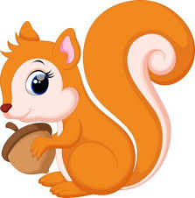
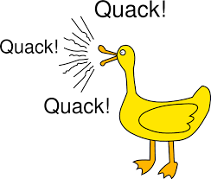
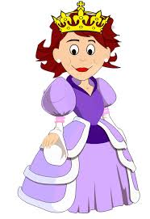
qu

queen quack squirrel

Song
The duck in the pond
quacks, “/qu/-/qu/-/qu/,”
“/qu/-/qu/-/qu/,”
“/qu/-/qu/-/qu/.”
The duck in the pond
quacks, “/qu/-/qu/-/qu/,”
all around the pond.
Read qu ee n qu a ck l i qu i d

qu i t qu i ck qu i z qu i l t s qu a sh
ai oa ie ee or ng z w y v oo x ch qu
Read 1

- The queen is rich.
- The yellow duck can quack a lot.
- A short test is a quiz.
- Milk is a good liquid.
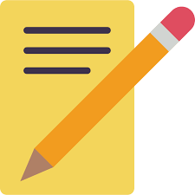
- Squash is a food.
Write
1.______________________________________________________

2.______________________________________________________

3.______________________________________________________

4.______________________________________________________

5._______________________________________________________

Read Circle qu

Quentin’s Duck

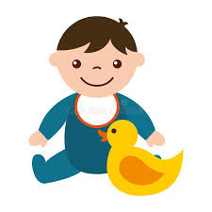
Quentin’s duck went
“Quack! quack! quack!”
Q-U-A-C-K
Though Quentin tried
To teach him more,
“Quack!” was all he’d say.

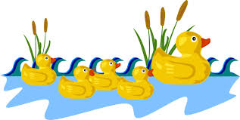
Quack! Quack!
The little ducklings went to play.
They all quickly swim away.
When mother duck says quack, quack, quack
all her ducklings come swimming back.
Quack, quack, quack!

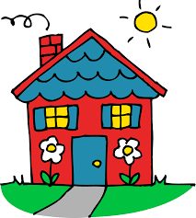
Ou
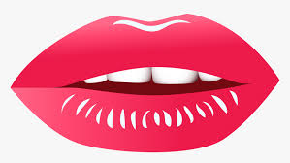

house mouth cloud
Song
I pricked my thumb
with a needle.
/ou/-/ou/-/ou/!
/ou/-/ou/-/ou/!
I pricked my thumb
With a needle.
/ou/-/ou/, ouch!

Read c ou n t m ou th c l ou d

ou t l ou d f ou n d r ou n d
ai oa ie ee or ng z w y v oo x ch qu ou
Read

- Sam’s mouth is red and round.
- I found a red and green egg in a basket.
- Shout the words out loud.
- The big cloud will rain soon.
- Pat can count to a hundred.
Write
1.______________________________________________________

2.______________________________________________________

3.______________________________________________________

4.______________________________________________________

5._______________________________________________________

Read Circle ou

Mouse Got an Ouch
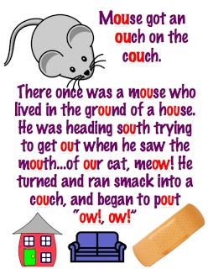

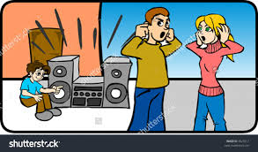
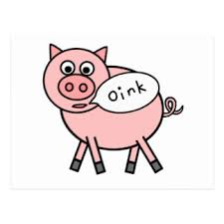
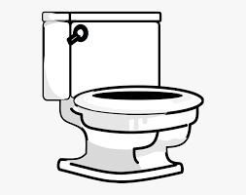
oi

toilet oink noise

Song
The sailors met upon
the sea,
/oi/-/oi/, /oi/-/oi/,
/oi/.
They found some oil
way down deep.
/oi/-/oi/, “Ship ahoy!”

Read p oi n t b oi l t oi l e t

oi n k c oi n p oi s o n j oi n
ai oa ie ee or ng z w y v oo x ch qu ou oi
Read

- The fat pink pig can yell, oink, oink, oink.
- A nickel is a coin. A half dollar is a coin.
- Point at the fast train.
- Cook fries in hot oil.
- Flush the toilet. Then join the class.
Write
1.______________________________________________________

2.______________________________________________________

3.______________________________________________________

4.______________________________________________________

5._______________________________________________________

Read Circle oi

My Worm is Not a Noisy Pet

My worm is not a noisy pet
when curling in a coil.
It mostly likes to toil inside
the moisture of the soil.

