Name__________________________________________
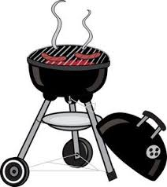
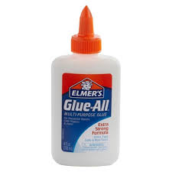
ue

blue glue barbecue

Song

I’d like to have a barbecue.
/ue/-/ue/-/ue/,
/ue/-/ue/-/ue/.
I’d like to have a
barbecue
with you, and you,
and you!
Read S ue b l ue g l ue d ue

t r ue c o n t i n ue s t a t ue
ai oa ie ee or ng z w y v oo x ch qu ou oi ue
Read
1. Sue’s dress is blue. Sue’s coat is blue, too.
2. That is true. Sam’s hat is blue, too.
3. Pat has glue on his blue pants.
4. The dog continues to jump up for food.
5. Mom and dad will rescue the cat in the tree.
Write
1.______________________________________________________

2.______________________________________________________

3.______________________________________________________

4.______________________________________________________

5._______________________________________________________

Read Circle ue

ue
Sticky Glue

A dot here, a dot there,
a dot of glue everywhere!
I glue blue feathers on my hat
and my shoes!
I glue blue ribbon to my shirts and boots
Glue is my favorite, no really!
It’s true!
What is your favorite thing to do?

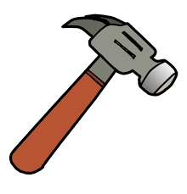
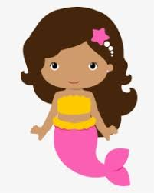
Er

computer hammer mermaid
Song
The mixer in the bowl
goes /er/-/er/-/er/,
/er/-/er/-/er/,
/er/-/er/-/er/.
The mixer in the bowl
goes /er/-/er/-/er/,
mixing the food
together.
Read s i s t er l a dd er
f a s t er u n d er h er
b i gg er m er m ai d
ai oa ie ee or ng z w y v oo x ch qu ou oi ue er
Read
- Jan is my sister. Tom is my brother.
- Dan can run. Sam runs faster.
- Sirena is a mermaid on Guam.
- I see Pat’s feet under his desk.
- Dad climbs up the ladder to fix the roof.
Write

1.______________________________________________________

2.______________________________________________________

3.______________________________________________________

4.______________________________________________________

5._______________________________________________________
Read Circle er

Tiger

ERRRRRR I’m so angry!
That tiger came over,
came over again.
His brother, his sister,
his mother, came too.
Now I’m all full of fur,
all thanks to her.

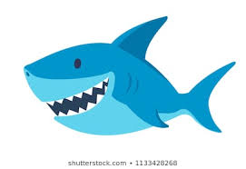
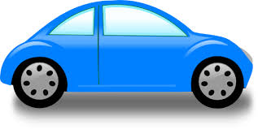
ar

car star shark
Song
“Open wide,”
the doctor said.
/ar/! /ar/!
Let me look
at your sore throat.
Please say, “/ar/!”

Read c ar s t ar ar t
ar m j ar p ar k f ar
M ar s p ar k f ar m

ai oa ie ee or ng z w y v oo x ch qu ou oi ue er ar
Read
- Mark has a car in the yard.
- Carl and Pam are in the park.
- The dog barks at the car.
- Bart went to the large farm.
- Mars is a star that is far.
Write

1.______________________________________________________

2.______________________________________________________

3.______________________________________________________

4.______________________________________________________

5._______________________________________________________
Read Circle ar
The Pirate Sound ar
There once was a pirate long ago
Who loved the a-r sound you know.
When he saw a word with an a and r
You could hear him call near and far:

Car, jar-ar, ar, ar
Tar, star-ar, ar, ar
Hard, bar-ar, ar, ar

Arm, harm, charm.
That pirate sailed the ocean blue
In search of gold and silver, too.
But the greatest treasure that there could be
Was an a-r word that he could read.

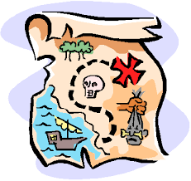
Far, scar-ar, ar, ar
Mars, cars-ar, ar, ar
Start, cart- ar, ar, ar
Hard, card, lard.
Ar, ar
Ar, ar
Ar, ar
An a-r word says ar, ar.

